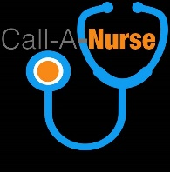

**BUSINESS PROPOSAL**

**TITLE:**

**GUARANTEED 90 DAYS ROI**

**PROJECT:**

[**www.callanurse.com.ng**](http://www.callanurse.com.ng)

**Temporary URL:** [**www.callanurse.godaddysites.com**](http://www.callanurse.godaddysites.com)

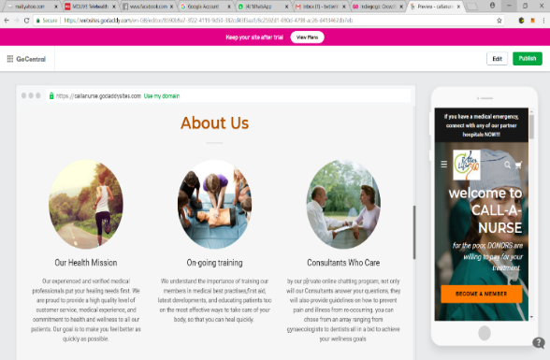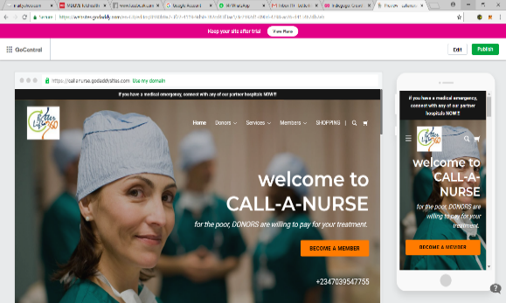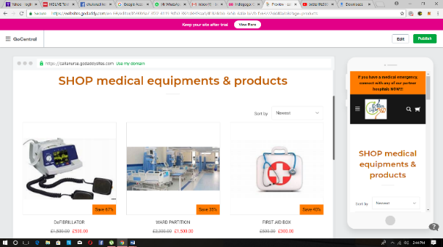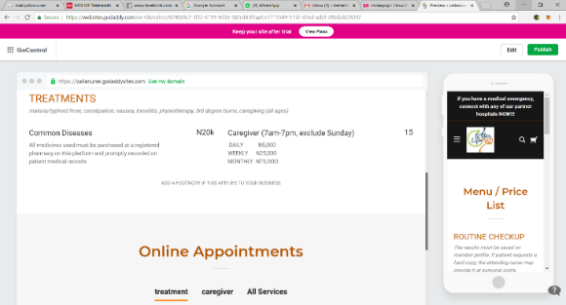

***NON-DISCLOSURE CLAUSE***

*Please keep the information here confidential and do not share or discuss it with anyone except the person who forwarded it to you as replication of same concept after this day, without prior permission from the MMBS team will be viewed as a copyright infringement and will attract legal action. You have been forwarded this information electronically as a likely investor in the* ***first phase*** *of this project during which N1,150,000 will be raised and paid back to the private investor on or before 1st Nov. 2018 at a minimum 10% interest per month calculated from August 1st. investors in this phase will also be given the offer of first refusal during the actual incorporation of the company on 1st Nov. 2018. Please communicate with the sender for more information or delete it if uninterested.*

**SYNOPSIS**

The call-a-nurse project, is an e-Health service based on internationally approved ICT services, in line with the United Nations Global Alliance for Information Communication Technologies and Development (UNGAID).

For the purposes of this proposal, ICTs are defined as tools that facilitate communication, processing and transmission of information and the sharing of knowledge by electronic means. This encompasses the full range of electronic digital and analog ICTs, from radio and television to telephones (fixed and mobile), computers, and electronic-based media such as digital text, audio-video recording, the Internet, mobile phone applications, social media networking and web-based communities. **Applying it to the health industry in Nigeria has never been done until now**.

In simple terms, CALLANURSE is where customers (patients) can get value for services including but not limited to getting the location, contact and services of the nearest available nurse, caregiver, online consultant, specialists, hospitals, pharmacies and laboratories for personalized home treatment of common diseases, caregiving (chIldren/adults) and consultancy. There is also a shopping service for healthy goods, hospital equipment and supplies. So its technology is a combination of the schema for UBER, JUMIA and lots more.

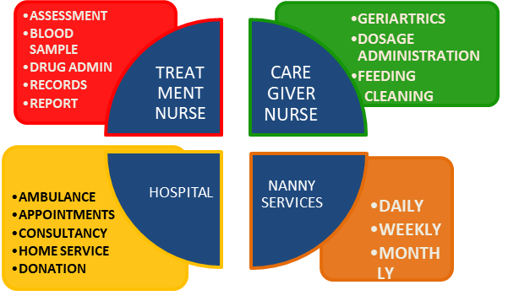

**IMPORTERS  
PHARMAc COYS.  
NGOs  
GOVT. AGENCIES  
TELCOS**

**LABS  
PHARMACY  
ONLINE SHOP**

ORDERS

PARTNERS

policy

**TARGET AUDIENCE**

**The General Public** (individuals or organizations) will have free access to call a nurse and pay for services like routine checks, home service/treatment/caregiving subject to the terms and conditions we shall provide. Free registration gives access to the public chat room where all may join ongoing discussions on various health topics and remedies or rather link with a consultant online for a session charged on our own payment system.

**Nurses** will register as freelance or hospital staff and will receive on-going training and rating based on qualification, experience, recommendation, customer satisfaction and quality of service rendered. All nurses will work closely with registered service partners.

**Hospitals** who join us, will be enabled to advertise their location and services online. They can also do group registrations for their doctors, consultants and nurses. Most importantly, we will give partner hospitals online access to hospital management software amongst many other freebies.

**Laboratories** and **Pharmacy’s** will also register as service partners to advertise their location and services online. While individual customers may make orders from any location, Nurses will order from the Pharmacy closest to the point of call.

**Online shoppers** will enjoy specialized services for their money’s worth. The vendors on this platform will also be subject to our online agreement while some may be verified by the necessary regulatory bodies, depending on the goods offered. for sale.

**VISION**

* Provide a database of patients’ medical history for all functional hospitals in Nigeria for proper health information management
* Create USSD functionality to the rural areas where medical assistance is unavailable or scarce for proper electronic integrated disease surveillance and response system (eiDSR)
* Create a Fund for Herbal Remedies Research and diseases relating to the environment, ageing and predictive medicine.
* Make medical intervention by donors easier through collaboration with relevant NGOs

**AIM & OBJECTIVES**

* Connect the sick with healthcare providers at all levels
* Promote e-Health in all its entirety including electronic health records, health care networks, telemedicine, computer-assisted surgeries, computer-assisted prescription checks for incompatibilities, contraindications, dosage levels, analytics for patient-lifestyle and professional ethics rating (feedback and reporting)
* Increase general well-being and life expectancy through a deliberate scheme named (RoCh) Routine Check-up for company staff and individuals
* Create an online payment system, through Telcos, for the unbanked
* Integrate realtime CHATKIT functionality (public and private) for registered members only (general, private consultancy{*timed*}, admin)
* Newsletter and online feeds for the general public

**SWOT ANALYSIS**

* Market monopoly/pioneer entry
* ICT and Branding team
* Professionals as Directors
* Careful research
* Startup Fund
* Company Board of Dirs.
* Office, SOP and AUDIT
* PHARMACY registration for online sales
* Correspondence with partner orgs(e.g NNANM)
* Define tokenized payment system
* Health insurance
* Nanny services
* Define Quality standards
* Adverts and feeds
* Startup-Time constraints
* Regulatory bodies
* Emergency response time
* Sexual harassment and policy

**LOCATION**

**Short Term**: LAGOS.  
**Mid term**: ABUJA, PORT HARCOURT, OYO, ONDO, OGUN, NASSARAWA, KADUNA, JOS, EDO&KANO  
**Long Term**: NATIONAL  
**Strategic** : ECOWAS STATES

**DELIVERABLES** (FIRST QUARTER)

* Private Placement & Investment Agreement
* Office location and Standard Operating Procedure (Partner Hospital)
* Registration of at least 3,000 proffesionals/partner services
* Marketers (4-6) will get 25% of activated revenue target of N6m
* Four Medical Staff for RoCh (Routine Check) Services
* Rigorous Social Media Hype
* Partnerships with NNANM and PSN for Training and accreditation

|  |  |  |  |  |  |  |
| --- | --- | --- | --- | --- | --- | --- |
| REGISTRATIONS | Monthly no. of persons | 1st quarter | COST N | TOTAL  N | 25% deduct | GROSS N |
| Nurses | **400** | **1200** | **1000** | **1,200,000** | **300,000** | **900,000** |
| Hospitals | **200** | **600** | **1000** | **600,000** | **150,000** | **450,000** |
| Laboratories | **200** | **600** | **1000** | **600,000** | **150,000** | **450,000** |
| Pharmacies | **200** | **600** | **1000** | **600,000** | **150,000** | **450,000** |
| RoCh | **50** | **150** | **20,000** | **3,000,000** | **750,000** | **2,250,000** |
|  |  |  |  | **6,000,000** |  | **4,500,000** |

**TIMELINE/MILESTONES (Phase 1 only)**

**I.T. and   
BRAND TEAM**meet for  
synergy at temp. office. T&C   
agreed   
upon

**E & M meet**for I.T. and BRAND TEAM   
_______  
Temporary job offer letter to shortlisted   
marketers.  
**prepare for monday13/08 Mkters  
Training**

**SOFT LAUNCH**SOCIAL MEDIA  
& beta 1   
Website.______  
send letters to   
NNANM  
PSN  
PSN

**Market  
Field Test**\*Alimosho  
*Eti-osa  
*Ikeja  
**RoChe**

**Marketing  
begins.**sign acceptance letters and share mkting tools______  
Progress  
Report to all PP.  
members

**Interview& Selection of Marketers**(4-6 nos). **_______  
TASK B1234**  
**research**  
*marketing tools  
*insurance partner  
*LASSA  
*Healthcare   
networks/ HMO &NGOs  
*first DONOR

**Private   
Placement   
Agreement**COMPLETED  
  
**TASK A123  
activate**  
*picture sessions   
*BTL branding  
*legal counsel

AUG 15

US

SEPT 1

US

AUG 25

US

AUG 18 - 22

US

AUG 16

US

AUG 17

US

SEPT 3-5

US

beta 2.0  
web and   
mobile App released.  
_______  
**TASK C12**  
**DONATION CALLS begin**

Visit   
*OldPeople Home  
*orphanage  
*psychiatric

End all  
**TASKS A&B**show events online and begin to compile report

**WHITE WALK** with the DJs  
2018.  
_____  
Pay Initial 10% for PP

**VISIT TO   
NNANM**secure Partnership. Give branded materials.   
source partners for white walk 2018

**VISIT TO   
PSN**secure Partner  
ship. Give branded materials.  
source partners for white walk 2018

OCT 15

US

NOV 1

US

**HEALTH WORKERS TRAINING**with   
RED CROSS  
NNANM  
_____  
Pay Second 10% for PP  
_________  
**Adverts/feeds  
begin**

**NANNY TRAINING**with   
RED CROSS  
NNANM  
 _________  
**TASK D**  
research online payment systems

beta 3.0  
web and   
mobile App released.  
_______  
**TASK C12**  
give back  
mkting

ONLINEdept.  
for HEALTHY SHOPPING  
*feel good  
*Safety  
*food

SEPT 10

SEPT 25

US

OCT 1

US

# PROJECT STATUS

## BUDGET (PHASE 1) 3 months

|  |  |  |  |  |  |
| --- | --- | --- | --- | --- | --- |
| Description | UNIT Value  N | Qty | status | Paid | Balance N |
| SOFTWARE |  |  |  |  |  |
| e-Health Program research | 50,000 |  | ongoing | 50,000 |  |
| Schema and Solutions Architecture | 50,000 |  | ongoing | 50,000 |  |
| Website front end | 80,000 |  |  | 50,000 | 30,000 |
| Website back end | 160,000 |  |  |  | 160,000 |
| Mobile app | 100,000 |  |  |  | 100,000 |
| Domain name/Hosting/Security/Plugins(chatkit etc) | 160,000 |  |  | 1500 | 158,500 |
| ADMIN LOGISTICS |  |  |  |  |  |
| Placement Partners Meeting | 30,000 | 2 |  |  | 60,000 |
| I.T., LAWYER and BRAND TEAM meet | 20,000 | 2 |  |  | 40,000 |
| Branding, BTL (SHIRT, CAP, STICKER, HAND BAND, NOTEPAD) | 100,000 | 1 |  |  | 100,000 |
| Stationeries and Posting (letters) | 10,000 | 1 |  |  | 10,000 |
| Social media hype | 120,000 | 3 months |  |  | 120,000 |
| Market Survey(Alimosho, ikeja, maryland) | 2,500 | 4 days |  |  | 10,000 |
| Interview panel(4 days) |  |  |  |  |  |
| Evaluation and Monitoring | 20,000 | 1 |  |  | 20,000 |
| RoCheck team ( 2 staff) | 30,000 | 2 |  |  | 60,000 |
| Marketing team | 5,000 | 6 |  |  | 30,000 |
| Miscellaneous | 100,000 | lot |  |  | 100,000 |
| TOTAL | **1,150,000** |  |  | **151,500** | **998,500** |

## BUDGET (PHASE 2) 12 months

|  |  |  |  |  |  |
| --- | --- | --- | --- | --- | --- |
| Office and furnishings | 2,500,000 | Lot |  |  | 2,500,000 |
| Project Vehicle (Hiace) | 2,000,000 | 1 |  |  | 2,000,000 |
| Branding | 500,000 | Lot |  |  | 500,000 |
| Staff (6) | 300,000 | 12 |  |  | 3,600,000 |
| LASAA | 100,000 | 1 |  |  | 100,000 |
| Float (consolidated funds) | 1,300,000 | Lot |  |  | 1,300,000 |
|  |  |  |  |  | **10,000,000** |

RECOMMENDATION

The domain callanurse.com is already sold since 2014 but callanurse.org is still available and may be bought by someone else if prompt action is not taken as soon as possible.

* Develop an agreement for the private placement partners who will contribute the required balance of N998,500 and kick off the project
* Chose the hospital to use as temporary office for now
* Register the business name CALLANURSE
* Follow the project timeline religiously
* Develop online terms and conditions
* Create at least 5 Donor-beneficiary stories
* Invest in car stickers and BTLs for visibility

Please consider this a viable investment that will yield dividends and cause a disruption in the medical industry, especial as we intend to partner with various Government agencies to legitimize this noble concept. All payments should be made to More Money Business Support, First bank account 2015482785

Regards.

**Busayo Innocent Manuwa.** (Project Manager)

07039547755. busayomanuwa@yahoo.com



